DDL COMMANDS WITH CONSTRAINTS

1)NOT NULL:

2)UNIQUE:

3)PRIMARY KEY:

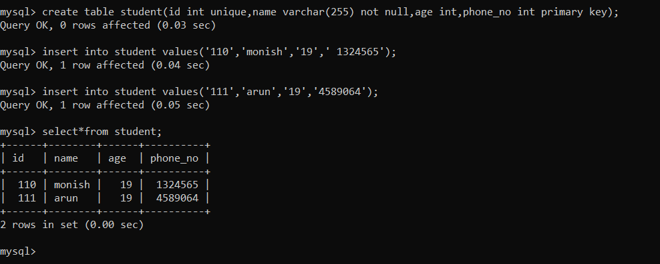

4)foreign key:

5)check:

